**Compiler design**

**Keerthi Rohan**

**CH.EN.U4CSE22030**

**Exercise 1**

1. Aim : Write a Lex program to count number of lines, spaces and etc.

Code :

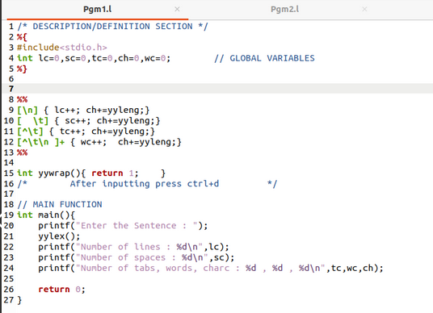

Output :

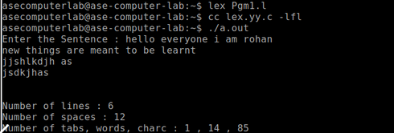

1. Aim : Write a Lex program to count number of words in given sentence.

Code :

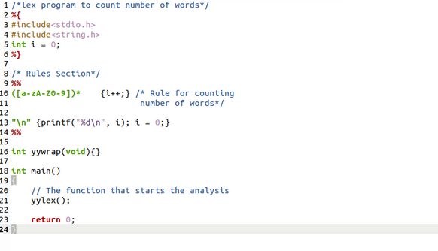

Output :

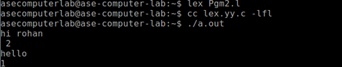

1. Aim : Write a Lex program to check whether the given number is even or odd

Code :

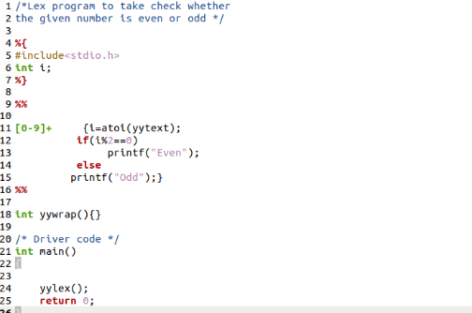

Output :

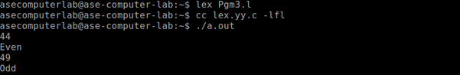

1. Aim : Write a Lex program to count the positive numbers, negative numbers and fractions.

Code :

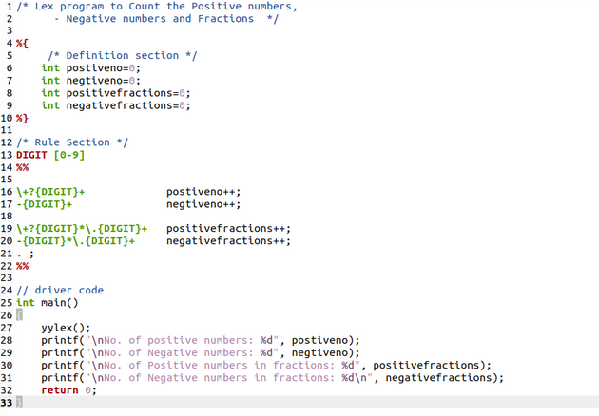

Output :

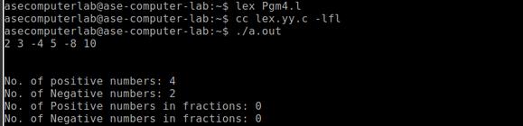

1. Aim : Write a Lex program to count the vowels and consonants in the given string

Code :

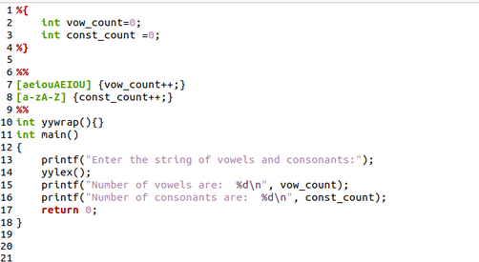

Output :

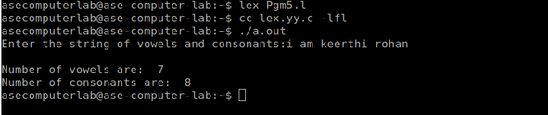

**Exercise 2**

1. Aim: To implement eliminate left recursion and left factoring from the given grammar using C program.

Algorithm:

Left Factoring:

* Start the processes by getting the grammar and assigning it to the appropriate

variables

* Find the common terminal and non-terminal elements and assign them in a

separate grammar

* Display the new and modified grammar.

Code:

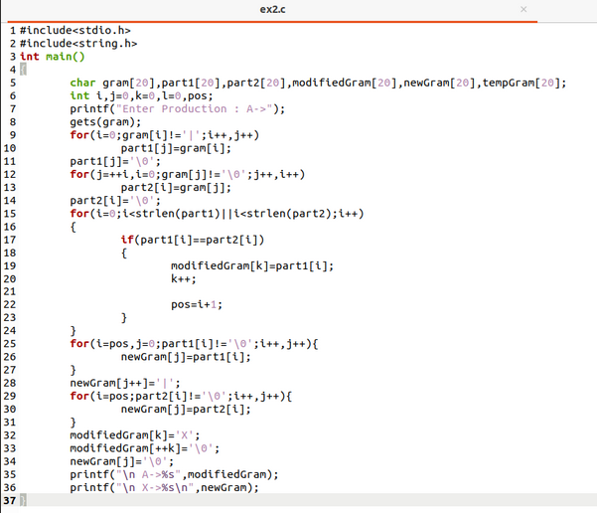

Output:

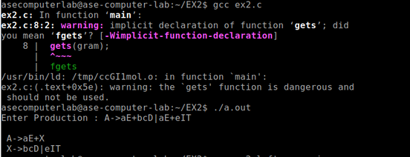

Left recursion:

1. Aim: To implement left recursion using C.

Algorithm:

* Start the processes by getting the grammar and assigning it to the appropriate

variables.

* Check if the given grammar has left recursion.
* Identify the alpha and beta elements in the production.
* Print the output according to the formula to remove left recursion

Code:

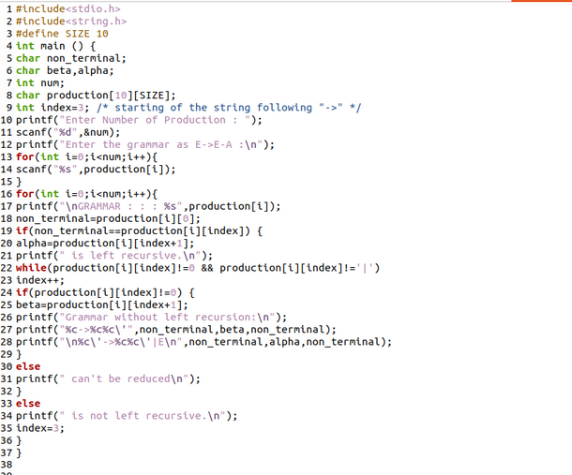

Output:

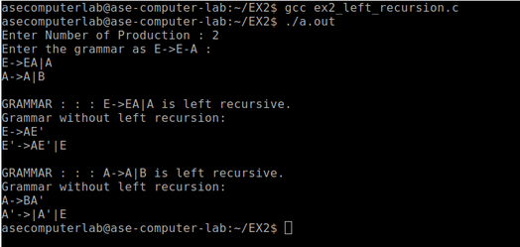

Result: The program to implement left factoring and left recursion has been successfully executed.